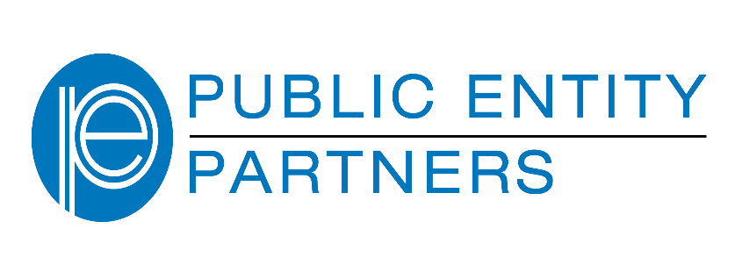
Driver Safety reimbursable items include:

Expenditures for employee driver safety technologies such as GPS tracking systems, backup cameras and alarms and alert systems for administrators (such as vehicle black box technology) which may assist to monitor compliance of vehicle use policies. In addition, on site instructor-led training, driving simulators, computer-based training (DVD’s) and train-the-trainer programs are all acceptable expenditures. This Grant is designed to address general Driver Safety. This program is not designed to address Emergency Vehicle Operations.

Please read this information in its entirety before completing the application:

- Public Entity Partners will reimburse up to 50 % of the cost of the driver safety-related approved item(s) with a maximum reimbursement based on the Priority Classification matrix rating.

This grant may also be used to cover 100 % of the cost of MVR checks (up to your entity’s classification eligibility), subject to a maximum of what the MVR expenses when obtaining through the Tennessee Department of Safety. You must maintain evidence of MVR checks in your records, if requested, to show a paper trail and have an action plan in place for those MVR checks that come back to you with an adverse driving record. Please contact Tahtia Mitchell, Grant & Scholarship Program at 1-800-624-9698 or Tmitchell@PEpartners.org for further details.

2) Matching grant funds must be used for employee driver safety related items.

3) Applicants must currently have automobile liability coverage with Public Entity Partners as of 7/1/2024.

4) Applicants must be in good standing with Public Entity Partners and in compliance with previous loss control recommendations.

OBJECTIVE: To help members with auto liability coverage purchase driver safety related items designed to reduce automobile liability claims.
2024-2025 James L. Richardson Driver
Matching Grant Program Guidelines

We are pleased to announce the launch of the 17th annual
Driver Matching Grant Program

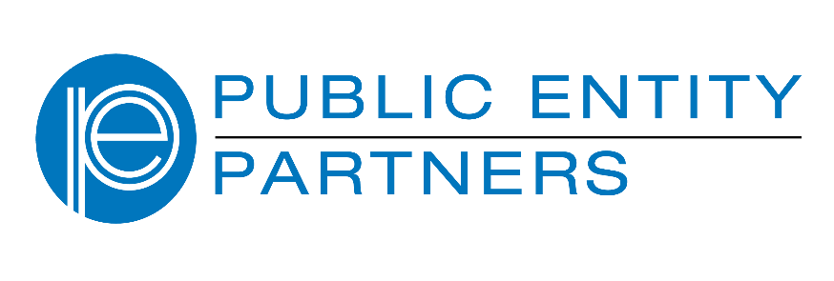

RULES FOR PARTICIPATION

1. Applications must be submitted online. The application is DATE SENSITIVE and is subject to available funds.

2. A signed Resolution or Motion (by the appropriate official: mayor or chairman of the board) passed by the governing body of the city/agency MUST BE provided. For boards of local government agencies that do not pass resolutions, a Motion is attached and may be signed by the appropriate Executive. In addition, also available on our website, please find a “fillable” Model Resolution/Motion, for your convenience.

NOTE: If your resolution/motion cannot be approved and signed when your application is ready, you may submit the application only. However, the resolution/motion must be sent by no later than December 1, 2024. Since the application is date sensitive, it is NOT necessary to submit the application and resolution/motion together. Please note that your grant reimbursement check will not be sent to you until we have received the document.

3. Public Entity Partners will reimburse approved grants for one-half of the paid expenditures (50 percent) up to the maximum funding level for the participant’s assigned classification.

4. If the Grant Committee approves your application, you will be asked to submit proof of payment(s) for your driver safety-related purchased item(s) before we can process your grant check. Invoices alone will NOT be used as proof of payment. Please see Page 3 for mandatory checklist of items needed for Grant reimbursement.

DEADLINE: Friday, October 25, 2024
GRANT NOTIFICATION DATE: Week of November 18, 2024
ELIGIBILITY: Members with Auto Liability Coverage since July 1, 2024. Your expenditure may be made between July 1, 2023 and April 1, 2025.
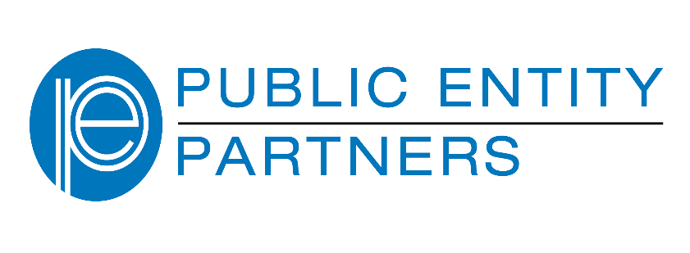

GRANT REIMBURSEMENT CHECKLIST:

- “Notification of Approval” letter
- Signed Resolution/Motion
- Cover sheet listing description of items purchased, quantities, and grand total of all purchases. All receipts must follow in order of the cover sheet.
- Two proofs of payment which must include the following:
  - CANCELLED check/bank statement OR credit card receipt/credit card statement OR Automated Clearing House (ACH) OR Automated Funds Transfer (AFT)
  - Copy of invoice OR purchase order (serving as the backup to the cancelled check or credit card receipt). Submitting invoices alone will not be accepted.

Forward all receipts/documentation to:
Tahtia Mitchell
Grant & Scholarship Program
Tmitchell@PEpartners.org
Fax: 615-371-9212

5. The deadline for us to receive your application and close this program is October 25, 2024. Grant notifications will be distributed the week of November 18, 2024.
6. Only ONE grant application may be approved for each entity during any given FISCAL YEAR. You may not “roll-over” an application from one fiscal year to another.
7. If approved for a grant, your proof of payment for expenditures must be received in this office by April 1, 2025, or your grant money WILL be awarded to the next “pending” member’s application.

5. If training is provided by an outside source, safety training must be conducted by a qualified driving instructor who meets the following minimum requirements:
(a) Must be at least twenty-one (21) years of age, high school graduate or passed the GED, have and maintain a valid driver license that has not been revoked, suspended or cancelled for any reason in the three (3) years preceding the date of hire, no conviction for a felony or any crime involving violence, dishonesty, deceit, fraud, or indecency.

(b) Must have attended and successfully completed a Driver Safety Instructors School operated by AAA, National Safety Council or such other certified school approved by The Pool. A copy of the instructor’s certificate of driver training completion must be included in the grant application along with the name, address, and telephone number of the school providing the certification. The instructor shall maintain a current certification.

6. The deadline for us to receive your application and close this program is Friday, September 29, 2017 (close of business). Approval/pending/non-approval grant notifications will be distributed the week of October 26, 2017.

7. Only ONE grant application may be approved for each town/city/agency during any given FISCAL YEAR. You may not “roll-over” an application from one fiscal year to another.

8. Total all estimates and final paid receipts!

9. If approved for a grant, your proof of payment for expenditures must be received in this office by May 1, 2018, or your grant money WILL be awarded to the next “pending” member’s application.

GRANT CONSIDERATIONS: Consideration of grants will be based on a variety of issues, such as your entity’s risk management practices, loss experience, and availability of funding and submission date.

- The primary consideration will be the amount of available funding for the fiscal year.

2. Priority will be given to risk exposures noted in the loss control site surveys, recommendations and/or loss trends, and a history of sound risk management practices.

Grant funding will depend on the earned automobile liability premium from the previous year. You may contact Tahtia Mitchell at TMitchell@PEpartners.org to inquire about your classification.
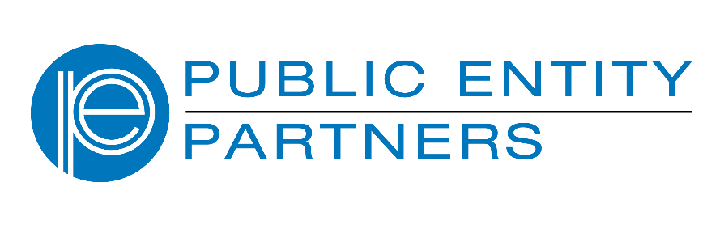
If you need to know about your classification or if you have additional questions, please contact:
Tahtia Mitchell
Grant & Scholarship Program
Tmitchell@PEpartners.org
1-800-624-9698

Automobile Liability Coverage Classification Levels

Class I — Contributed earned premium for the previous year $40,000 or more in the requested coverage area.
Class II — Contributed earned premium for the previous year between $20,000 and $39,999 in the requested coverage area.
Class III —Contributed earned premium for the previous year between $10,000 and $19,999 in the requested coverage area.
Class IV — Contributed earned premium for the previous year between $6,000 and $9,999 in the requested coverage area.
Class V — Contributed less than $6,000 in automobile liability premium for the previous year in the requested coverage area.

Rating Classifications Funding Levels
(based upon earned automobile liability premium for previous year 2023-2024)

Class I — Up to $5,000
Class II — Up to $4,000
Class III — Up to $2,500
Class IV — Up to $1,000
Class V — Up to $500

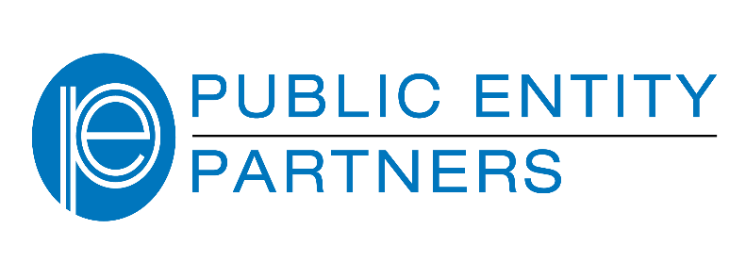

A RESOLUTION AUTHORIZING
___________________________________________
TO PARTICIPATE IN

James L. Richardson “Driver” Matching Grant Program

* * * * * * * * * * * * * * * * * * *

WHEREAS, the safety and well-being of the employees of the City of ____________________________________ is of the greatest importance; and

WHEREAS, all efforts shall be made to provide a safe and hazard-free workplace for the City of ______________________________ employees; and

WHEREAS, Public Entity Partners seeks to encourage the establishment of a safe workplace by offering a “Driver” Matching Grant Program; and

WHEREAS, the City of ____________________________________now seeks to participate in this important program.

NOW, THEREFORE, BE IT RESOLVED BY THE COUNCIL OF THE CITY OF __________________________, TENNESSEE the following:

SECTION 1. That the City of ________________________________ is hereby authorized to submit application for a “Driver” Matching Grant Program through Public Entity Partners.

SECTION 2. That the City of _________________________________ is further authorized to provide a matching sum to serve as a match for any monies provided by this grant.

Resolved this ________ day of _____________________ in the year of ___________.

____________________________________
Mayor
ATTEST:

_________________________________________
City Recorder

MODEL RESOLUTION
FOR GOVERNMENTAL ENTITIES
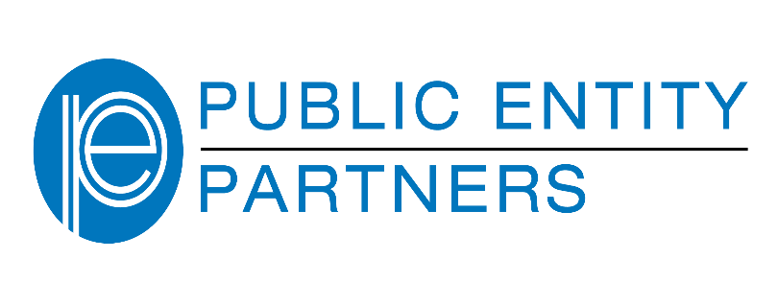

A MOTION AUTHORIZING ______________________________________
TO PARTICIPATE IN

James L. Richardson “Driver”
Matching Grant Program

* * * * * * * * * * * * * * * * * * * * *

WHEREAS, the safety and well-being of the employees of _______________________ __________________________________________________is of the greatest importance; and

WHEREAS, all efforts shall be made to provide a safe and hazard-free workplace for the __________________________________________________ employees; and

WHEREAS, Public Entity Partners seeks to encourage the establishment of a safe workplace by offering a “Driver” Matching Grant Program; and

WHEREAS, the ___________________________________________________now seeks to participate in this important program.

I, therefore, move that the ______________________________________________ is hereby authorized to submit application for a “Driver” Matching Grant Program through Public Entity Partners ; and that the _____________________________ is further authorized to provide a matching sum to serve as a match for any monies provided by this grant.

A motion was made by ___________________________________________________ and properly seconded, and then passed on by the Board on _________________________ day of __________________________________ in the year of ___________.

____________________________________
Appropriate Signature

MODEL MOTION

FOR GOVERNMENTAL ENTITIES
THAT DO NOT UTILIZE RESOLUTIONS

